Aim: To implement a Decision Tree algorithm using Python

Software Required
- Python 3.x
- Jupyter Notebook
- Libraries: pandas, numpy, scikit-learn, matplotlib

Q1. What are Decision Trees?
Decision Trees are a supervised machine learning algorithm used for both classification and regression tasks. They work by recursively splitting the data based on feature values to form a tree-like structure where:
- Internal nodes represent decision rules based on features
- Branches represent outcomes of those decisions
- Leaf nodes represent final predictions (class labels or continuous values)

Q2. Explain different types of Decision Trees.
Type | Description | Use Case
Classification Trees | Predict categorical/discrete classes | Email spam detection, disease diagnosis
Regression Trees | Predict continuous/numerical values | House price prediction, sales forecasting
CART (Classification and Regression Trees) | Can handle both classification and regression | General-purpose tasks
ID3 (Iterative Dichotomiser 3) | Uses Information Gain with categorical data | Simple classification problems
C4.5 (Successor to ID3) | Handles both categorical and numerical data | Practical applications with mixed data
C5.0 | Improved version of C4.5, more memory efficient | Commercial applications

Q3. List Advantages of Decision Trees.
- Easy to Understand & Interpret: Visual representation makes it transparent
- Requires Little Data Pre-processing: No need for feature scaling or normalization
- Handles Both Numerical & Categorical Data
- Non-Parametric: No assumptions about data distribution
- Feature Importance: Naturally shows which features are most important
- Handles Non-Linear Relationships
- Fast Prediction: Once trained, predictions are O(log n)

Q4 List Disadvantages of Decision Trees.
- Overfitting: Tend to create overly complex trees that don't generalize well
- High Variance: Small changes in data can create very different trees
- Biased with Imbalanced Data: May create biased trees favouring dominant classes
- Not Suitable for XOR-type Problems: Struggle with certain logical operations
- Instability: Sensitive to minor variations in training data
- Greedy Algorithm: Makes locally optimal decisions that may not be globally optimal

Q5. Draw the Decision Tree using ID3 Induction Method.
Code:
import pandas as pd
import numpy as np
import matplotlib.pyplot as plt
from sklearn.tree import DecisionTreeClassifier, export_text, plot_tree
from sklearn.preprocessing import LabelEncoder

# Define the dataset
data = {
'Outlook': ['Sunny', 'Sunny', 'Overcast', 'Rain', 'Rain', 'Rain', 'Overcast',
'Sunny', 'Sunny', 'Rain', 'Sunny', 'Overcast', 'Overcast', 'Rain'],
'Temperature': ['Hot', 'Hot', 'Hot', 'Mild', 'Cool', 'Cool', 'Cool',
'Mild', 'Cool', 'Mild', 'Mild', 'Mild', 'Hot', 'Mild'],
'Humidity': ['High', 'High', 'High', 'High', 'Normal', 'Normal', 'Normal',
'High', 'Normal', 'Normal', 'Normal', 'High', 'Normal', 'High'],
'Windy': ['Weak', 'Strong', 'Weak', 'Weak', 'Weak', 'Strong', 'Strong',
'Weak', 'Weak', 'Weak', 'Strong', 'Strong', 'Weak', 'Strong'],
'PlayTennis': ['No', 'No', 'Yes', 'Yes', 'Yes', 'No', 'Yes', 'No', 'Yes',
'Yes', 'Yes', 'Yes', 'Yes', 'No']
}

# Create Data Frame
df = pd.DataFrame(data)
print("Dataset:")
print(df)
print("\n" + "="*50)

# Features and target
features = ['Outlook', 'Temperature', 'Humidity', 'Windy']
target = 'PlayTennis'

# Prepare data for sklearn
X = df[features]
y = df[target]

# Encode categorical variables
le = LabelEncoder()
X_encoded = X.copy()
for col in X.columns:
X_encoded[col] = le.fit_transform(X[col])

y_encoded = le.fit_transform(y)

print("\nEncoded Features:")
print(X_encoded.head())
print(f"\nEncoded Target (0=No, 1=Yes): {y_encoded}")

# Build decision tree with entropy criterion (similar to ID3)
dt_clf = DecisionTreeClassifier(
criterion='entropy', # This makes it similar to ID3
max_depth=3,
random_state=42
)

dt_clf.fit(X_encoded, y_encoded)

# Visualize the tree
plt.figure(figsize=(15, 10))
plot_tree(
dt_clf,
feature_names=features,
class_names=['No', 'Yes'],
filled=True,
rounded=True,
fontsize=10
)
plt.title("ID3-like Decision Tree (using scikit-learn)", fontsize=16)
plt.tight_layout()
plt.show()

# Print tree rules
print("\n" + "="*50)
print("Decision Tree Rules:")
print("="*50)
tree_rules = export_text(
dt_clf,
feature_names=features,
spacing=3,
decimals=2
)
print(tree_rules)

# Feature importance
print("\n" + "="*50)
print("Feature Importance:")
print("="*50)
for feature, importance in zip(features, dt_clf.feature_importances_):
print(f"{feature}: {importance:.3f}")

# Make predictions
print("\n" + "="*50)
print("Making Predictions:")
print("="*50)

# Example test cases
test_cases = [
{'Outlook': 'Sunny', 'Temperature': 'Hot', 'Humidity': 'High', 'Windy': 'Weak'},
{'Outlook': 'Rain', 'Temperature': 'Cool', 'Humidity': 'Normal', 'Windy': 'Strong'},
{'Outlook': 'Overcast', 'Temperature': 'Mild', 'Humidity': 'Normal', 'Windy': 'Weak'}
]

for i, test_case in enumerate(test_cases):
# Encode the test case
encoded_case = []
for feature in features:
# Get the label encoder for this feature
le = LabelEncoder()
le.fit(df[feature]) # Fit with original data
encoded_value = le.transform([test_case[feature]])[0]
encoded_case.append(encoded_value)

prediction = dt_clf.predict([encoded_case])[0]
probability = dt_clf.predict_proba([encoded_case])[0]

print(f"\nTest Case {i+1}:")
print(f" Features: {test_case}")
print(f" Prediction: {'Yes (Play Tennis)' if prediction == 1 else 'No (Don\'t Play Tennis)'}")
print(f" Confidence: {probability[prediction]*100:.1f}%")
print(f" Probabilities: [No: {probability[0]:.2%}, Yes: {probability[1]:.2%}]")

Output:
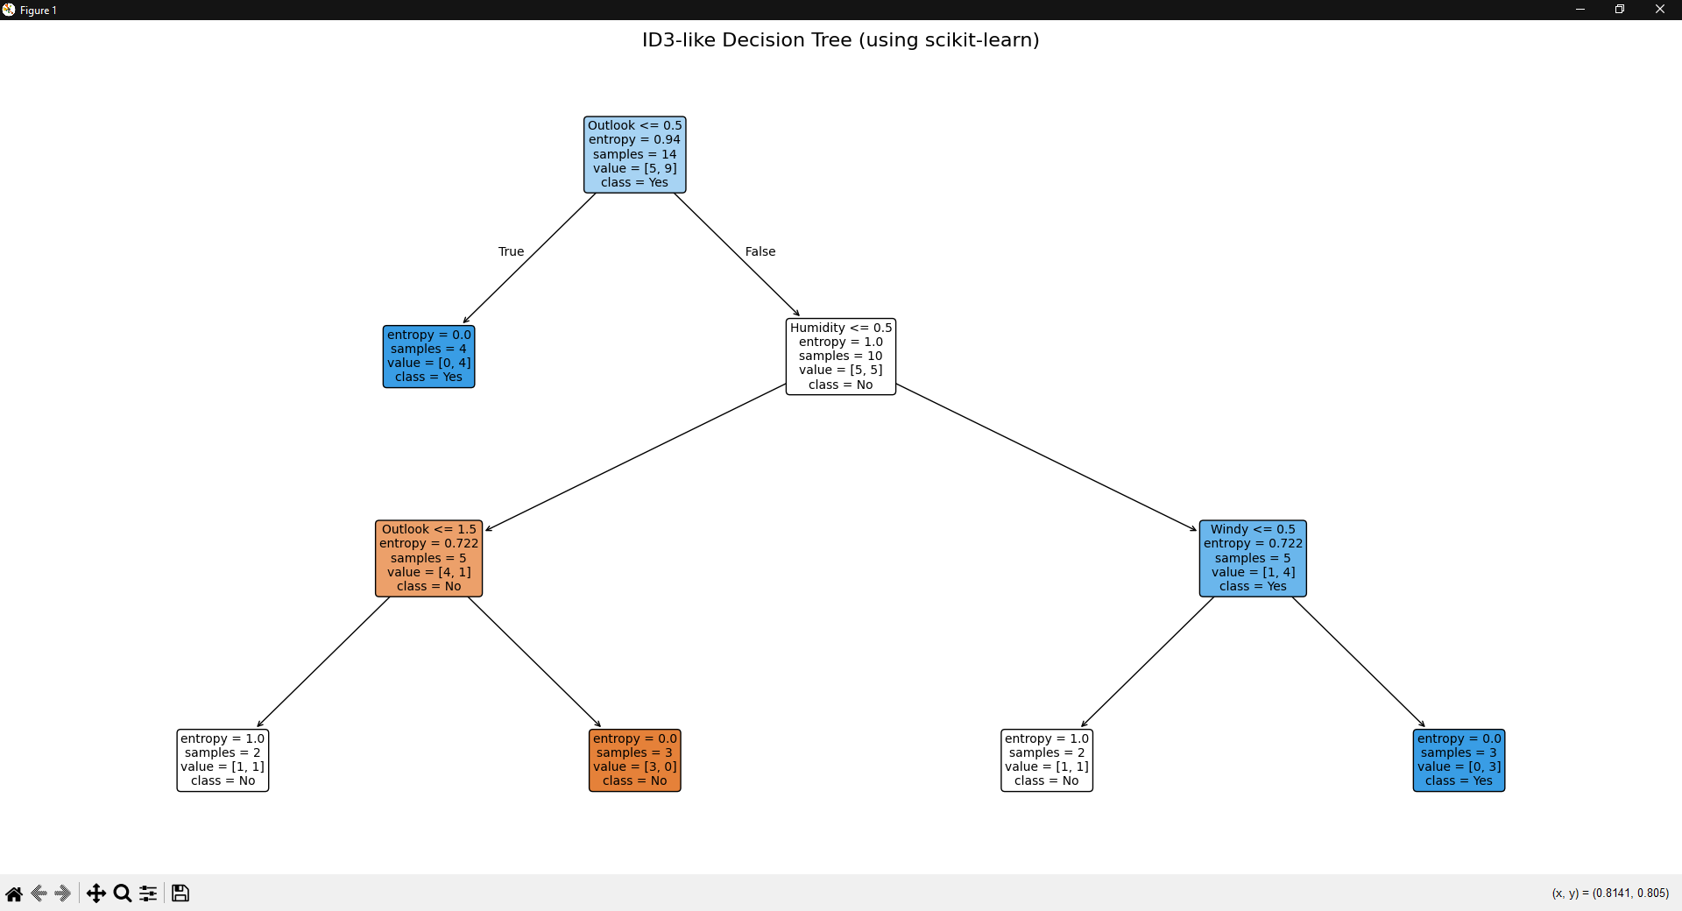

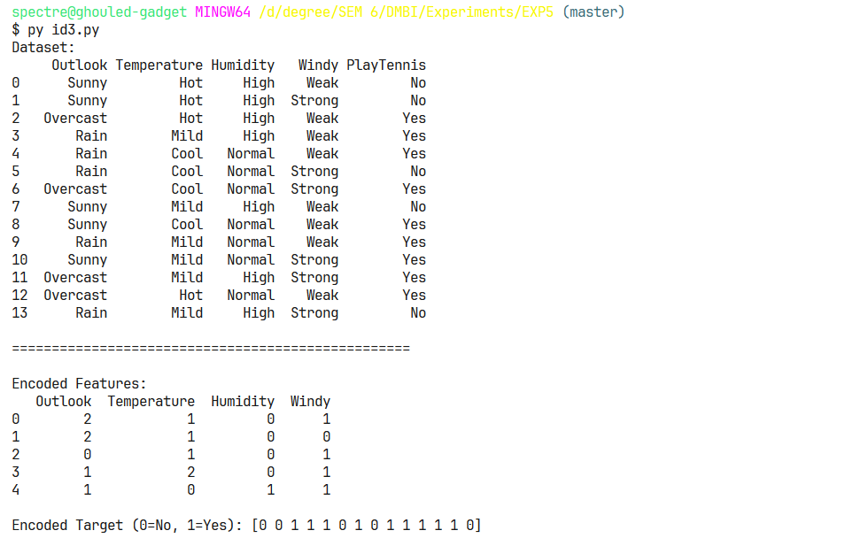

Q6. Create the Decision Tree using Naïve bayes Algorithm Method.
Code:
import pandas as pd
import numpy as np
import matplotlib.pyplot as plt
from sklearn.tree import DecisionTreeClassifier, plot_tree
from sklearn.preprocessing import LabelEncoder

data = {
'Outlook': ['Sunny', 'Sunny', 'Overcast', 'Rain', 'Rain', 'Rain', 'Overcast',
'Sunny', 'Sunny', 'Rain', 'Sunny', 'Overcast', 'Overcast', 'Rain'],
'Temperature': ['Hot', 'Hot', 'Hot', 'Mild', 'Cool', 'Cool', 'Cool',
'Mild', 'Cool', 'Mild', 'Mild', 'Mild', 'Hot', 'Mild'],
'Humidity': ['High', 'High', 'High', 'High', 'Normal', 'Normal', 'Normal',
'High', 'Normal', 'Normal', 'Normal', 'High', 'Normal', 'High'],
'Windy': ['Weak', 'Strong', 'Weak', 'Weak', 'Weak', 'Strong', 'Strong',
'Weak', 'Weak', 'Weak', 'Strong', 'Strong', 'Weak', 'Strong'],
'PlayTennis': ['No', 'No', 'Yes', 'Yes', 'Yes', 'No', 'Yes', 'No', 'Yes',
'Yes', 'Yes', 'Yes', 'Yes', 'No']}

df = pd.DataFrame(data)
features = ['Outlook', 'Temperature', 'Humidity', 'Windy']
target = 'PlayTennis'

le = LabelEncoder()
X_encoded = df[features].copy()
for col in features:
le.fit(df[col])
X_encoded[col] = le.transform(df[col])
y_encoded = le.fit_transform(df[target])

dt_clf = DecisionTreeClassifier(
criterion='entropy',
max_depth=3,
random_state=42
)
dt_clf.fit(X_encoded, y_encoded)
plt.figure(figsize=(20, 12))
plot_tree(
dt_clf,
feature_names=features,
class_names=['No', 'Yes'],
filled=True,
rounded=True,
fontsize=12,
proportion=True,
impurity=True,
node_ids=True,
precision=2
)
plt.title("Decision Tree - Tennis Play Prediction\n(Using ID3-like Algorithm with Entropy)", fontsize=16, fontweight='bold', pad=20)
plt.tight_layout()
plt.show()

Output:
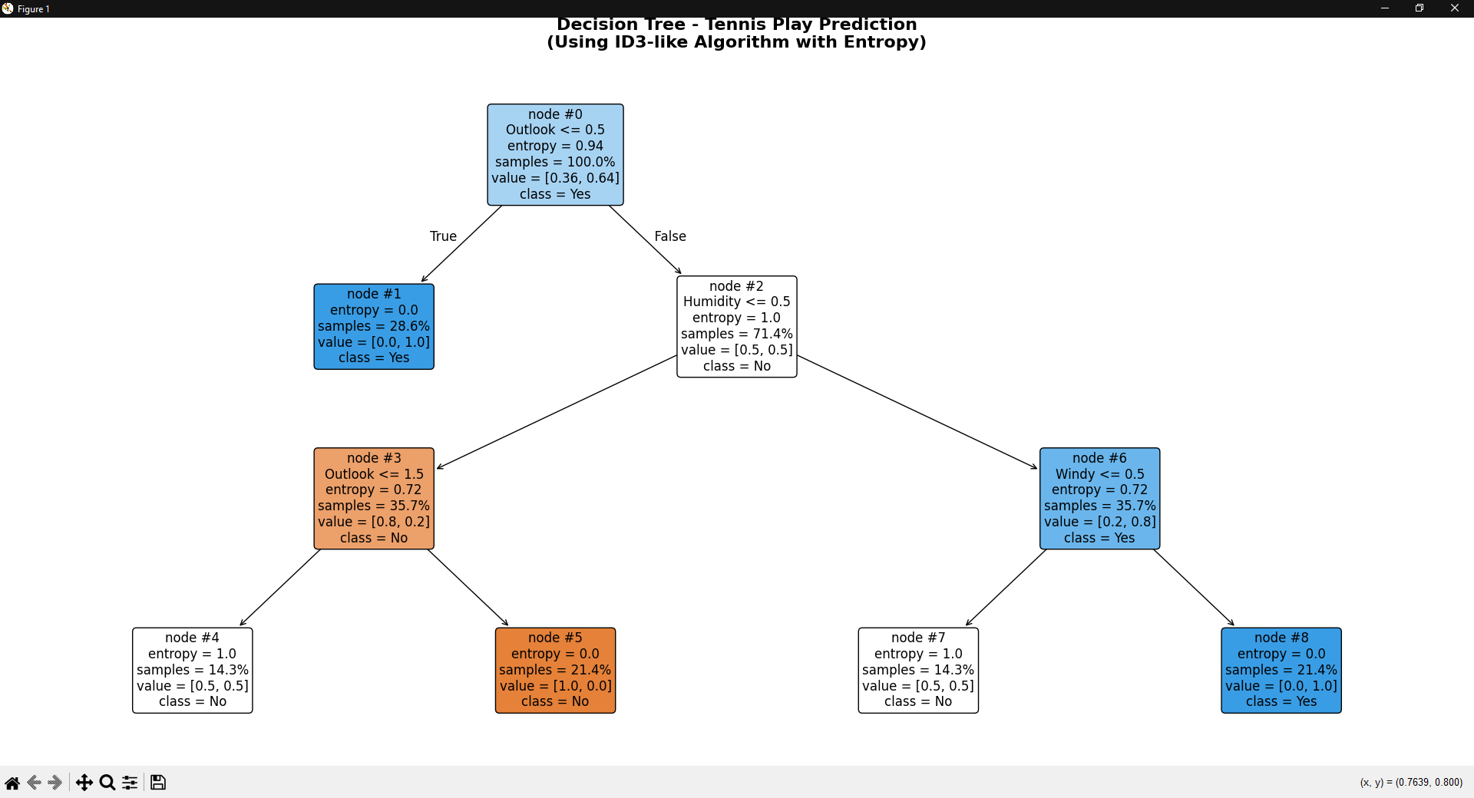

Q7. Write the Python Code for Decision Tree.

Code:
import pandas as pd
from sklearn.model_selection import train_test_split
from sklearn.tree import DecisionTreeClassifier, export_text, plot_tree
from sklearn.preprocessing import LabelEncoder
from sklearn.metrics import accuracy_score, classification_report
import matplotlib.pyplot as plt

df = pd.read_csv('vgsales.csv')

df['High_Seller'] = df['Global_Sales'].apply(lambda x: 1 if x > 5 else 0)

label_encoders = {}
categorical_cols = ['Platform', 'Genre', 'Publisher']

for col in categorical_cols:
le = LabelEncoder()
df[col + '_encoded'] = le.fit_transform(df[col].astype(str))
label_encoders[col] = le

features = ['Year', 'Platform_encoded', 'Genre_encoded', 'Publisher_encoded',
'NA_Sales', 'EU_Sales', 'JP_Sales', 'Other_Sales']

df_clean = df.dropna(subset=features + ['High_Seller'])

X = df_clean[features]
y = df_clean['High_Seller']

X_train, X_test, y_train, y_test = train_test_split(
X, y, test_size=0.3, random_state=42, stratify=y
)

dt_classifier = DecisionTreeClassifier(
max_depth=5,
min_samples_split=20,
min_samples_leaf=10,
random_state=42
)

dt_classifier.fit(X_train, y_train)

y_pred = dt_classifier.predict(X_test)

print(f"Accuracy: {accuracy_score(y_test, y_pred):.2%}")
print("\nClassification Report:")
print(classification_report(y_test, y_pred))

feature_importance = pd.DataFrame({
'feature': features,
'importance': dt_classifier.feature_importances_
}).sort_values('importance', ascending=False)

print("\nFeature Importance:")
print(feature_importance)

plt.figure(figsize=(20, 10))
plot_tree(
dt_classifier,
feature_names=features,
class_names=['Not High Seller', 'High Seller'],
filled=True,
rounded=True,
proportion=True,
fontsize=10
)
plt.title("Decision Tree for Video Game Sales Prediction")
plt.tight_layout()
plt.show()

print("\nDecision Tree Rules (first 5 levels):")
tree_rules = export_text(
dt_classifier,
feature_names=features,
max_depth=5
)
print(tree_rules)

Output:
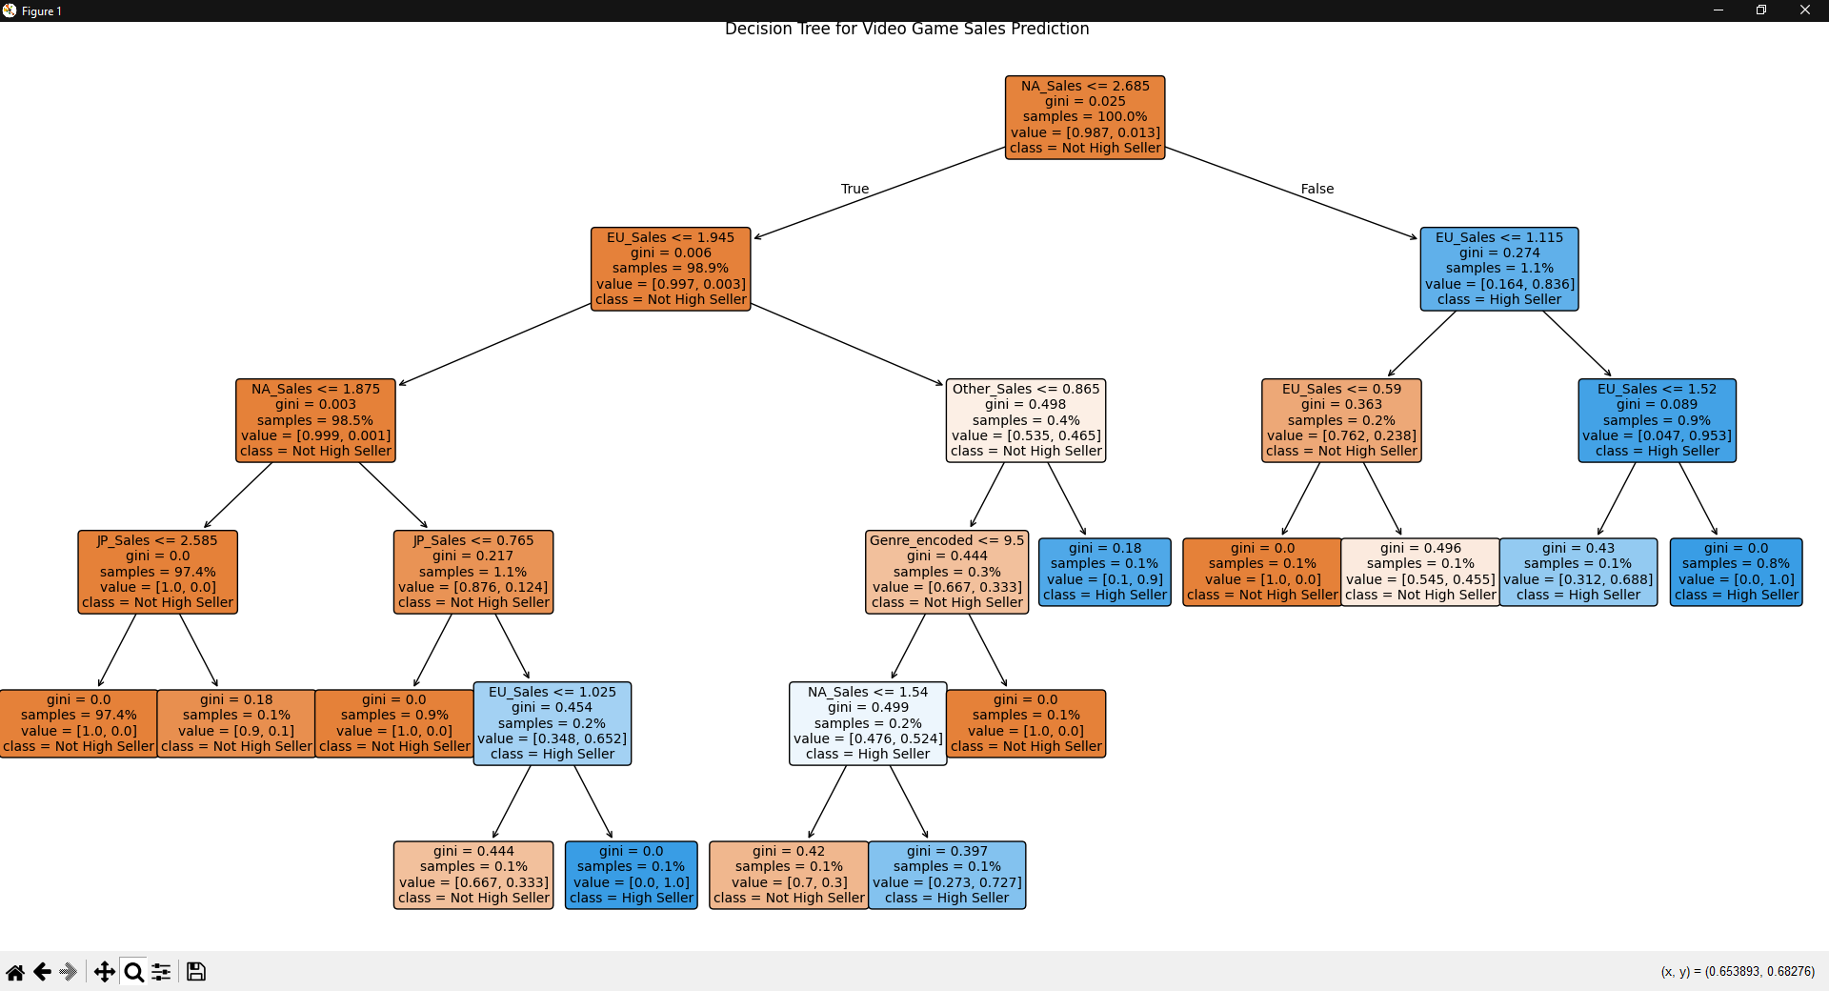

Conclusion:
Decision Trees create hierarchical decision rules that make predictions through intuitive, tree-structured models.

